24CSI024L-DATA STRUCTURES AND ALGORITHMS
UNIT 1-INTRODUCTION TO DATA STRUCTURES AND ALGORITHMS
Experiment:1. Squaring a Sorted Array Using Two-Pointer Technique
HADHISH R (25BAD029)

Aim
To write a C program to square each element of a sorted array and return the squared values in non-decreasing order using the Two-Pointer technique.
Algorithm
1. Read the number of elements N.
2. Read the sorted array.
3 Initialize:
- left = 0
- right = N - 1
- pos = N - 1
4.Compare the absolute values of arr[left] and arr[right].
5. Square the larger absolute value and store it in result[pos].
6. Move the corresponding pointer (left++ or right--).
7. Decrement pos.
8. Repeat until left > right.
9. Print the result array.
Program
#include <stdio.h>
#include <stdlib.h>
int main()
{
int n;
scanf("%d", &n);

int arr[n], result[n];

for(int i = 0; i < n; i++)
scanf("%d", &arr[i]);

int left = 0, right = n - 1;
int pos = n - 1;

while(left <= right)
{
if(abs(arr[left]) > abs(arr[right]))
{
result[pos] = arr[left] * arr[left];
left++;
}
else
{
result[pos] = arr[right] * arr[right];
right--;
}
pos--;
}

for(int i = 0; i < n; i++)
printf("%d ", result[i]);

return 0;
}
OUTPUT
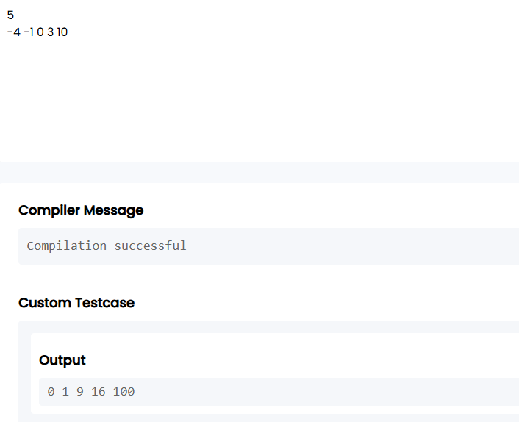

Result
Thus, the C program to square the elements of a sorted array and produce the squared values in sorted order using the Two-Pointer technique was implemented and executed successfully.
https://github.com/hadhishravi-cell/24CSI024L-25BAD029/blob/c8a05a53d48ea23af6285ccd13e139fc5be3acee/Ex%201.a.a

Experiment: 2. Cumulative Resource Consumption Using Prefix Sum
Aim
To write a C program to compute the cumulative running sum (Prefix Sum) of an array.
Algorithm
- Read the number of elements N.
- Read the array elements.
- Create a prefix sum array.
- Set prefix[0] = arr[0].
- For each element from index 1 to N-1, compute:
  - prefix[i] = prefix[i-1] + arr[i]
- Print the prefix sum array.
Program
#include <stdio.h>
int main()
{
int n;
scanf("%d", &n);

int arr[n], prefix[n];

for(int i = 0; i < n; i++)
scanf("%d", &arr[i]);

prefix[0] = arr[0];

for(int i = 1; i < n; i++)
prefix[i] = prefix[i - 1] + arr[i];

for(int i = 0; i < n; i++)
printf("%d ", prefix[i]);

return 0;
}

Output

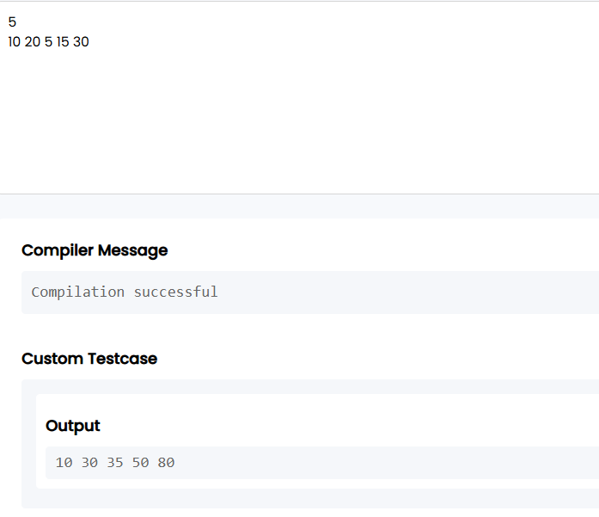

Result
Thus, the C program to compute the cumulative running sum (Prefix Sum) of an array was implemented and executed successfully.
https://github.com/hadhishravi-cell/24CSI024L-25BAD029/blob/c8a05a53d48ea23af6285ccd13e139fc5be3acee/Ex%201%20.b.b

Experiment: 3.Grouping Active Sectors Using Fixed-Size Sliding Window
Aim
To write a C program to find the minimum number of swaps required to bring all 1s together using the Fixed-Size Sliding Window technique.
Algorithm
- Read the number of elements N.
- Read the binary array.
- Count the total number of 1s and store it in count.
- If count is 0 or 1, print Min Swaps: 0.
- Count the number of 1s in the first window of size count.
- Slide the window through the array and keep track of the maximum number of 1s in any window.
- Calculate:
  - Minimum Swaps = count - maximum_ones
- Print the minimum swaps.
Program
#include <stdio.h>
int main()
{
int n;
scanf("%d", &n);

int arr[n];
int count = 0;

for(int i = 0; i < n; i++)
{
scanf("%d", &arr[i]);
if(arr[i] == 1)
count++;
}

if(count == 0 || count == 1)
{
printf("Min Swaps: 0");
return 0;
}

int ones = 0;

for(int i = 0; i < count; i++)
if(arr[i] == 1)
ones++;

int maxOnes = ones;
for(int i = count; i < n; i++)
{
if(arr[i - count] == 1)
ones--;

if(arr[i] == 1)
ones++;

if(ones > maxOnes)
maxOnes = ones;
}

printf("Min Swaps: %d", count - maxOnes);

return 0;
}

Output
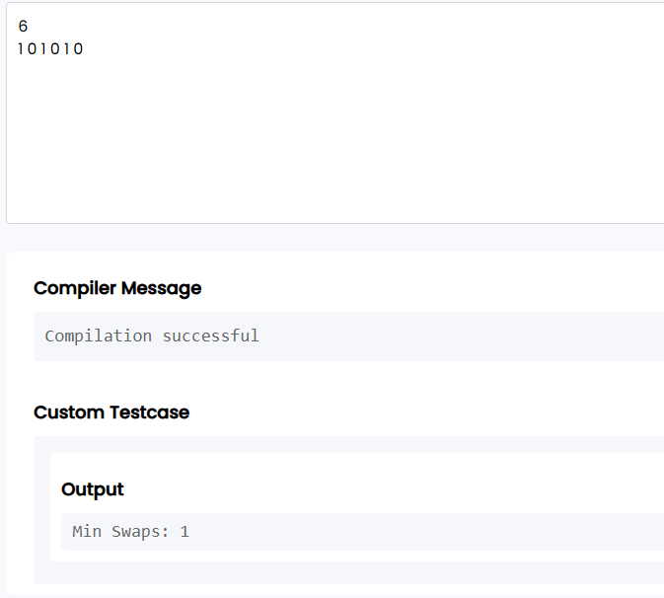

Result
Thus, the C program to find the minimum number of swaps required to group all 1s together using the Fixed-Size Sliding Window technique was implemented and executed successfully.

https://github.com/hadhishravi-cell/24CSI024L-25BAD029/blob/c8a05a53d48ea23af6285ccd13e139fc5be3acee/Ex%201c

Experiment: 4.Maximum Task Window Within Budget Using Variable-Size Sliding Window
Aim
To write a C program to find the maximum number of consecutive tasks whose total energy cost does not exceed the given limit using the Variable-Size Sliding Window technique.
Algorithm
- Read the values of N and P.
- Read the array of energy costs.
- Initialize:
  - start = 0
  - current_sum = 0
  - maxLength = 0
- Traverse the array using the end pointer.
- Add arr[end] to current_sum.
- While current_sum > P, subtract arr[start] from current_sum and increment start.
- Update maxLength with the maximum window size.
- Print Max Length.
Program
#include <stdio.h>
int main()
{
int n, p;
scanf("%d %d", &n, &p);

int arr[n];

for(int i = 0; i < n; i++)
scanf("%d", &arr[i]);

int start = 0;
int current_sum = 0;
int maxLength = 0;

for(int end = 0; end < n; end++)
{
current_sum += arr[end];

while(current_sum > p)
{
current_sum -= arr[start];
start++;
}

if(current_sum <= p)
{
int length = end - start + 1;
if(length > maxLength)
maxLength = length;
}
}

printf("Max Length: %d", maxLength);

return 0;
}
Output
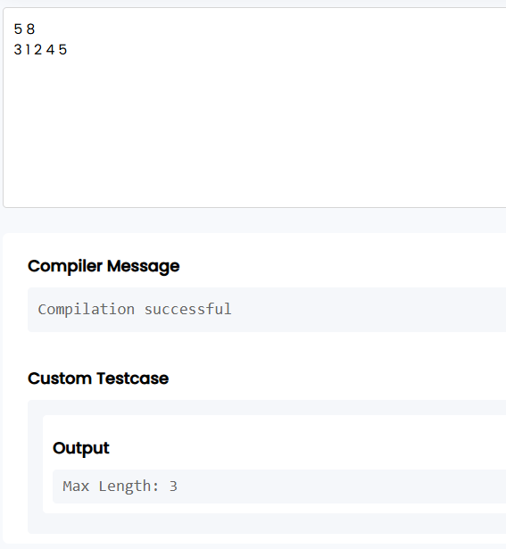

Result
Thus, the C program to find the maximum number of consecutive tasks within the given energy limit using the Variable-Size Sliding Window technique was implemented and executed successfully.
https://github.com/hadhishravi-cell/24CSI024L-25BAD029/blob/c8a05a53d48ea23af6285ccd13e139fc5be3acee/Ex%201d

Experiment: 5.Sliding Window Maximum Using Monotonic Queue (Deque)
Aim
To write a C program to find the maximum element in every sliding window of size K using the Monotonic Queue (Deque) technique.
Algorithm
- Read the values of N and K.
- Read the array elements.
- Create a deque using an array to store indices.
- For each element:
  - Remove indices from the front if they are outside the current window.
  - Remove indices from the rear while their corresponding values are less than or equal to the current element.
  - Insert the current index at the rear.
  - When the first window is formed, print the element at the front of the deque.
- Repeat until all windows are processed.
Program
#include <stdio.h>
int main()
{
int n, k;
scanf("%d %d", &n, &k);

int arr[n];
for(int i = 0; i < n; i++)
scanf("%d", &arr[i]);

int deque[n];
int front = 0, rear = -1;

for(int i = 0; i < n; i++)
{

while(front <= rear && deque[front] <= i - k)
front++;

while(front <= rear && arr[deque[rear]] <= arr[i])
rear--;
deque[++rear] = i;
if(i >= k - 1)
printf("%d ", arr[deque[front]]);
}

return 0;
}
Output
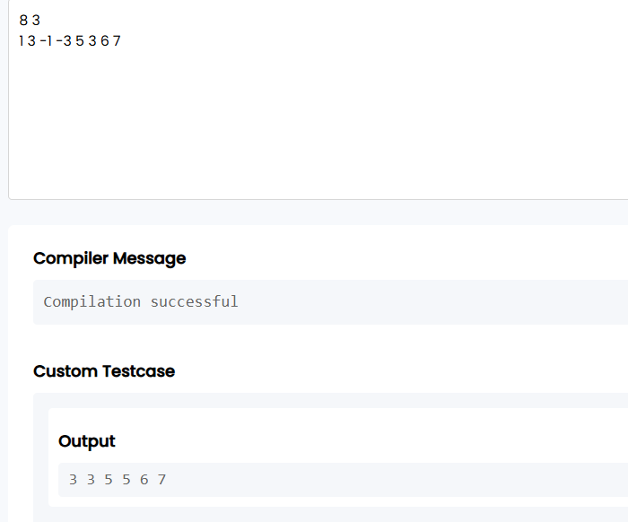
Result
Thus, the C program to find the maximum element in every sliding window of size K using the Monotonic Queue (Deque) technique was implemented and executed successfully.
https://github.com/hadhishravi-cell/24CSI024L-25BAD029/blob/c8a05a53d48ea23af6285ccd13e139fc5be3acee/Ex%201.e

